ANAGHA ACHARYA

1BM19CS224

**Consider the schema for College Database:**

**STUDENT (*USN, SName, Address, Phone, Gender*)**

**SEMSEC (*SSID, Sem, Sec*)**

**CLASS (*USN, SSID*)**

**SUBJECT (*Subcode, Title, Sem, Credits*)**

**IAMARKS (*USN, Subcode, SSID, Test1, Test2, Test3, FinalIA*)**

**Write SQL queries to**

1. List all the student details studying in fourth semester ‘C’ section.

2. Compute the total number of male and female students in each semester and in each section.

3. Create a view of Test1 marks of student USN ‘1BI15CS101’ in all subjects.

4. Categorize students based on the following criterion:

If FinalIA = 17 to 20 then CAT = ‘Outstanding’

If FinalIA = 12 to 16 then CAT = ‘Average’

If FinalIA< 12 then CAT = ‘Weak’

Give these details only for 8th semester A, B, and C section students.

create database college;

use college;

create table student(

usn varchar(10) primary key,

sname varchar(25),

address varchar(25),

phone int,

gender char(1));

desc student;

alter table student modify column phone bigint;

create table semsec(

ssid varchar(5) primary key,

sem int,

sec char(1));

desc semsec;

create table class(

usn varchar(10),

ssid varchar(5),

primary key(usn,ssid),

foreign key(usn) references student(usn),

foreign key(ssid) references semsec(ssid));

desc class;

create table subject(

subcode varchar(8),

title varchar(20),

sem int,

credits int,

primary key(subcode));

desc subject;

create table iamarks(

usn varchar(10),

subcode varchar(8),

ssid varchar(5),

test1 int,

test2 int,

test3 int,

finalia int,

primary key (usn,subcode,ssid),

foreign key (usn) references student (usn),

foreign key (subcode) references subject (subcode),

foreign key (ssid) references semsec (ssid));

desc iamarks;

insert into student values('1RN13CS020','AKSHAY','BELAGAVI', 8877881122,'M');

insert into student values('1RN13CS062','SANDHYA','BENGALURU', 7722829912,'F');

insert into student values('1RN13CS091','TEESHA','BENGALURU', 7712312312,'F');

insert into student values('1RN13CS066','SUPRIYA','MANGALURU', 8877881122,'F');

insert into student values ('1RN14CS010','ABHAY','BENGALURU', 9900211201,'M');

insert into student values ('1RN14CS032','BHASKAR','BENGALURU', 9923211099,'M');

insert into student values ('1RN14CS025','ASMI','BENGALURU', 7894737377,'F');

insert into student values ('1RN15CS011','AJAY','TUMKUR', 9845091341,'M');

insert into student values ('1RN15CS029','CHITRA','DAVANGERE', 7696772121,'F');

insert into student values ('1RN15CS045','JEEVA','BELLARY', 9944850121,'M');

insert into student values ('1RN15CS091','SANTOSH','MANGALURU', 8812332201,'M');

insert into student values ('1RN16CS045','ISMAIL','KALBURGI', 9900232201,'M');

insert into student values ('1RN16CS088','SAMEERA','SHIMOGA', 9905542212,'F');

insert into student values ('1RN16CS122','VINAYAKA','CHIKAMAGALUR', 8800880011,'M');

commit;

select * from student;

insert into semsec values('CSE8A', 8,'A');

insert into semsec values('CSE8B', 8,'B');

insert into semsec values('CSE8C', 8,'C');

insert into semsec values('CSE7A', 7,'A');

insert into semsec values('CSE7B', 7,'B');

insert into semsec values('CSE7C', 7,'C');

insert into semsec values('CSE6A', 6,'A');

insert into semsec values('CSE6B', 6,'B');

insert into semsec values('CSE6C', 6,'C');

insert into semsec values('CSE5A', 5,'A');

insert into semsec values('CSE5B', 5,'B');

insert into semsec values('CSE5C', 5,'C');

insert into semsec values('CSE4A', 4,'A');

insert into semsec values('CSE4B', 4,'B');

insert into semsec values('CSE4C', 4,'C');

insert into semsec values('CSE3A', 3,'A');

insert into semsec values('CSE3B', 3,'B');

insert into semsec values('CSE3C', 3,'C');

insert into semsec values('CSE2A', 2,'A');

insert into semsec values('CSE2B', 2,'B');

insert into semsec values('CSE2C', 2,'C');

insert into semsec values('CSE1A', 1,'A');

insert into semsec values('CSE1B', 1,'B');

insert into semsec values('CSE1C', 1,'C');

commit;

select * from semsec;

insert into class values ('1RN13CS020','CSE8A');

insert into class values ('1RN13CS062','CSE8A');

insert into class values ('1RN13CS066','CSE8B');

insert into class values ('1RN13CS091','CSE8C');

insert into class values ('1RN14CS010','CSE7A');

insert into class values ('1RN14CS025','CSE7A');

insert into class values ('1RN14CS032','CSE7A');

insert into class values ('1RN15CS011','CSE4A');

insert into class values ('1RN15CS029','CSE4A');

insert into class values ('1RN15CS045','CSE4B');

insert into class values ('1RN15CS091','CSE4C');

insert into class values ('1RN16CS045','CSE3A');

insert into class values ('1RN16CS088','CSE3B');

insert into class values ('1RN16CS122','CSE3C');

commit;

select * from class;

insert into subject values ('10CS81','ACA', 8, 4);

insert into subject values ('10CS82','SSM', 8, 4);

insert into subject values ('10CS83','NM', 8, 4);

insert into subject values ('10CS84','CC', 8, 4);

insert into subject values ('10CS85','PW', 8, 4);

insert into subject values ('10CS71','OOAD', 7, 4);

insert into subject values ('10CS72','ECS', 7, 4);

insert into subject values ('10CS73','PTW', 7, 4);

insert into subject values ('10CS74','DWDM', 7, 4);

insert into subject values ('10CS75','JAVA', 7, 4);

insert into subject values ('10CS76','SAN', 7, 4);

insert into subject values ('15CS51', 'ME', 5, 4);

insert into subject values ('15CS52','CN', 5, 4);

insert into subject values ('15CS53','DBMS', 5, 4);

insert into subject values ('15CS54','ATC', 5, 4);

insert into subject values ('15CS55','JAVA', 5, 3);

insert into subject values ('15CS56','AI', 5, 3);

insert into subject values ('15CS41','M4', 4, 4);

insert into subject values ('15CS42','SE', 4, 4);

insert into subject values ('15CS43','DAA', 4, 4);

insert into subject values ('15CS44','MPMC', 4, 4);

insert into subject values ('15CS45','OOC', 4, 3);

insert into subject values ('15CS46','DC', 4, 3);

insert into subject values ('15CS31','M3', 3, 4);

insert into subject values ('15CS32','ADE', 3, 4);

insert into subject values ('15CS33','DSA', 3, 4);

insert into subject values ('15CS34','CO', 3, 4);

insert into subject values ('15CS35','USP', 3, 3);

insert into subject values ('15CS36','DMS', 3, 3);

commit;

select * from subject ;

insert into iamarks (USN, SUBCODE, SSID, TEST1, TEST2, TEST3) values ('1RN13CS091','10CS81','CSE8C', 15, 16, 18);

insert into iamarks (USN, SUBCODE, SSID, TEST1, TEST2, TEST3) values ('1RN13CS091','10CS82','CSE8C', 12, 19, 14);

insert into iamarks (USN, SUBCODE, SSID, TEST1, TEST2, TEST3) values ('1RN13CS091','10CS83','CSE8C', 19, 15, 20);

insert into iamarks (USN, SUBCODE, SSID, TEST1, TEST2, TEST3) values ('1RN13CS091','10CS84','CSE8C', 20, 16, 19);

insert into iamarks (USN, SUBCODE, SSID, TEST1, TEST2, TEST3) values ('1RN13CS091','10CS85','CSE8C', 15, 15, 12);

commit;

select * from iamarks;

#Query1

select s.*, ss.sem,ss.sec

from student s, semsec ss, class c

where s.usn=c.usn and

ss.ssid=c.ssid and

ss.sem=4 and

ss.sec='C';

#Query2

select ss.sem,ss.sec,s.gender,count(s.gender)as count

from student s,semsec ss,class c

where s.usn=c.usn and

ss.ssid=c.ssid

group by ss.sem,ss.sec,s.gender

order by sem;

#Query3

create view student_test1

as select test1, subcode

from iamarks

where usn='1RN13CS091';

select * from student_test1;

#Query4

select s.usn,s.sname,s.address,s.phone,s.gender,

(case

when ia.finalia between 17 and 20 then 'outstanding'

when ia.finalia between 12 and 16 then 'average'

else 'weak'

end)

as cat

from student s, semsec ss, iamarks ia, subject sub

where s.usn = ia.usn and

ss.ssid = ia.ssid and

sub.subcode = ia.subcode and

sub.sem = 8;

OUTPUT:

STUDENT TABLE

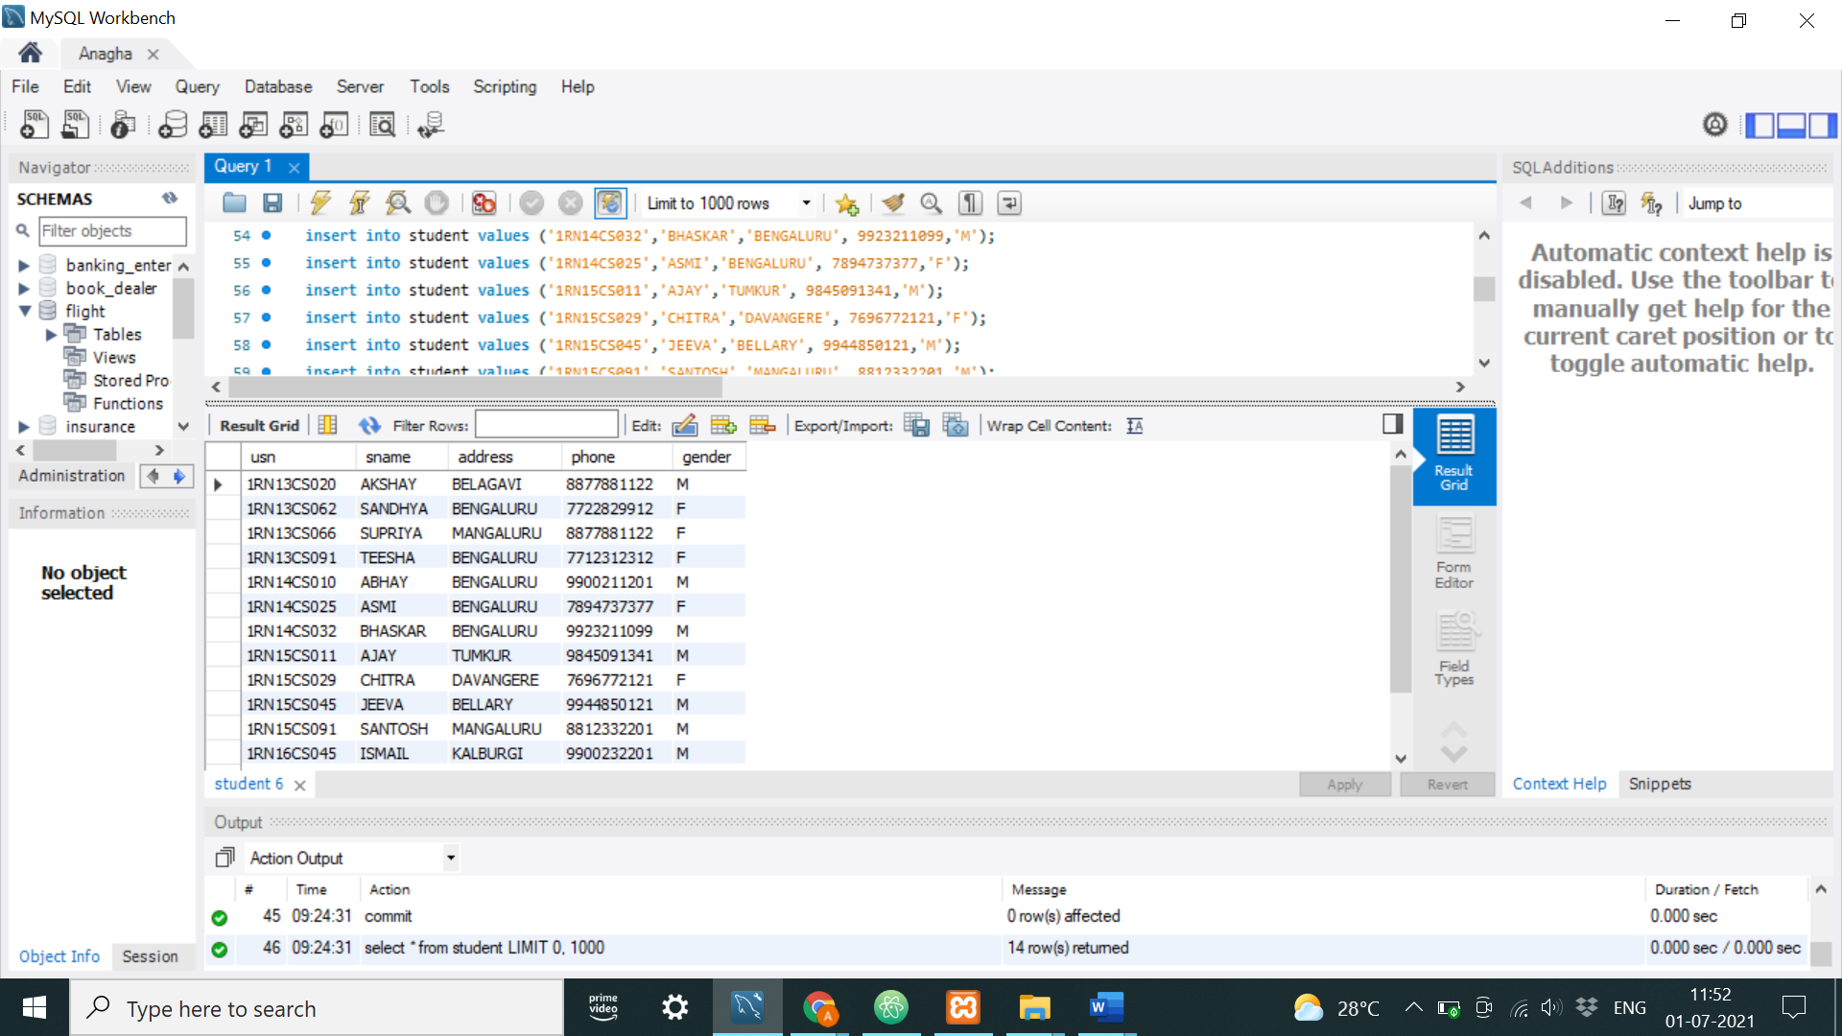

SEMSEC TABLE CLASS TABLE

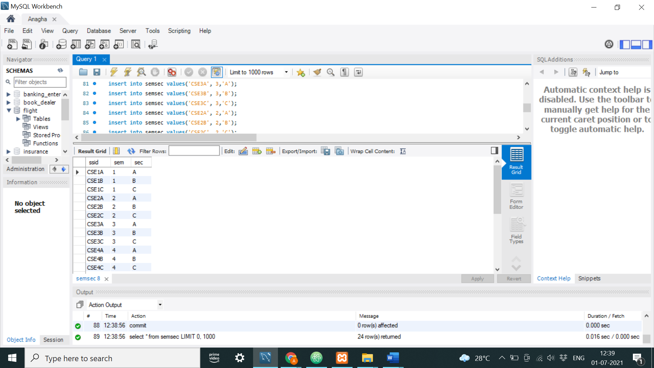 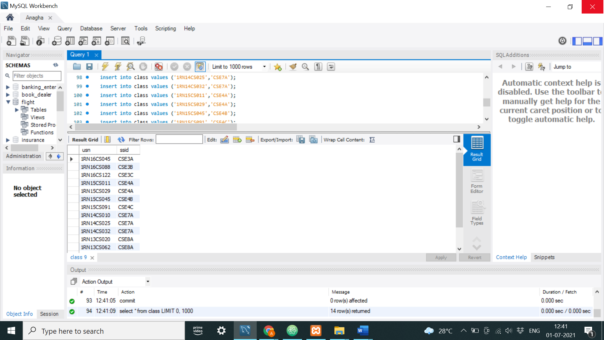

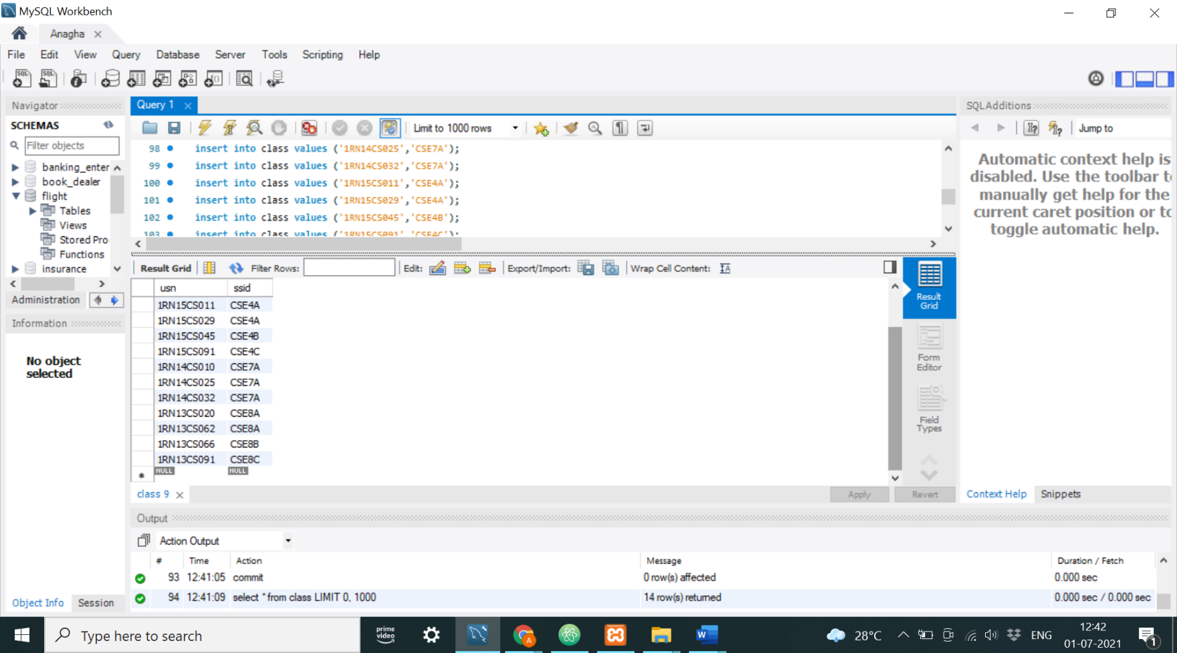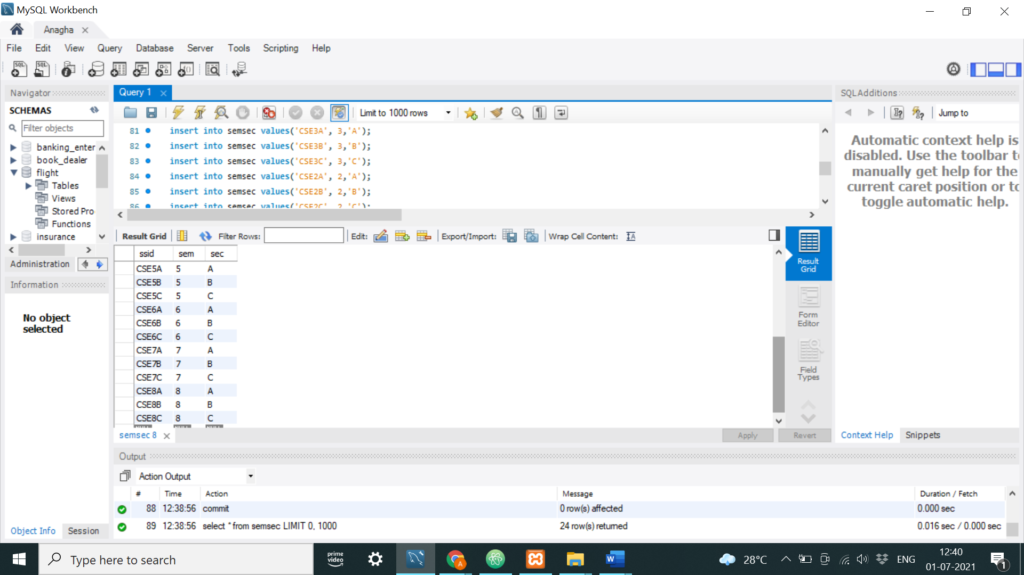

SUBJECT TABLE IAMARKS TABLE

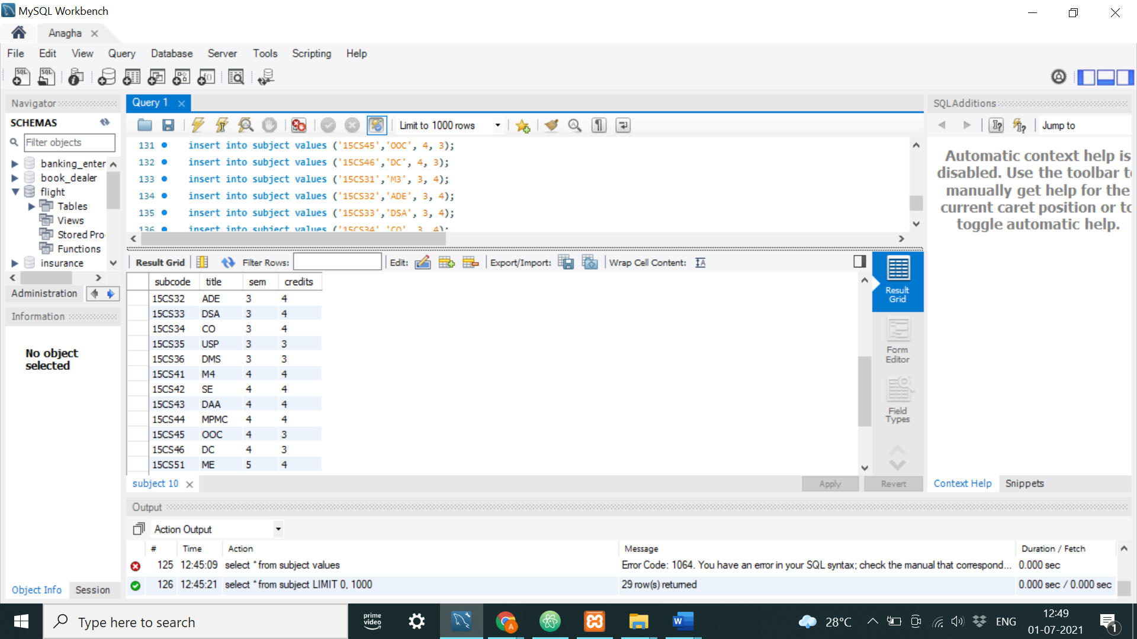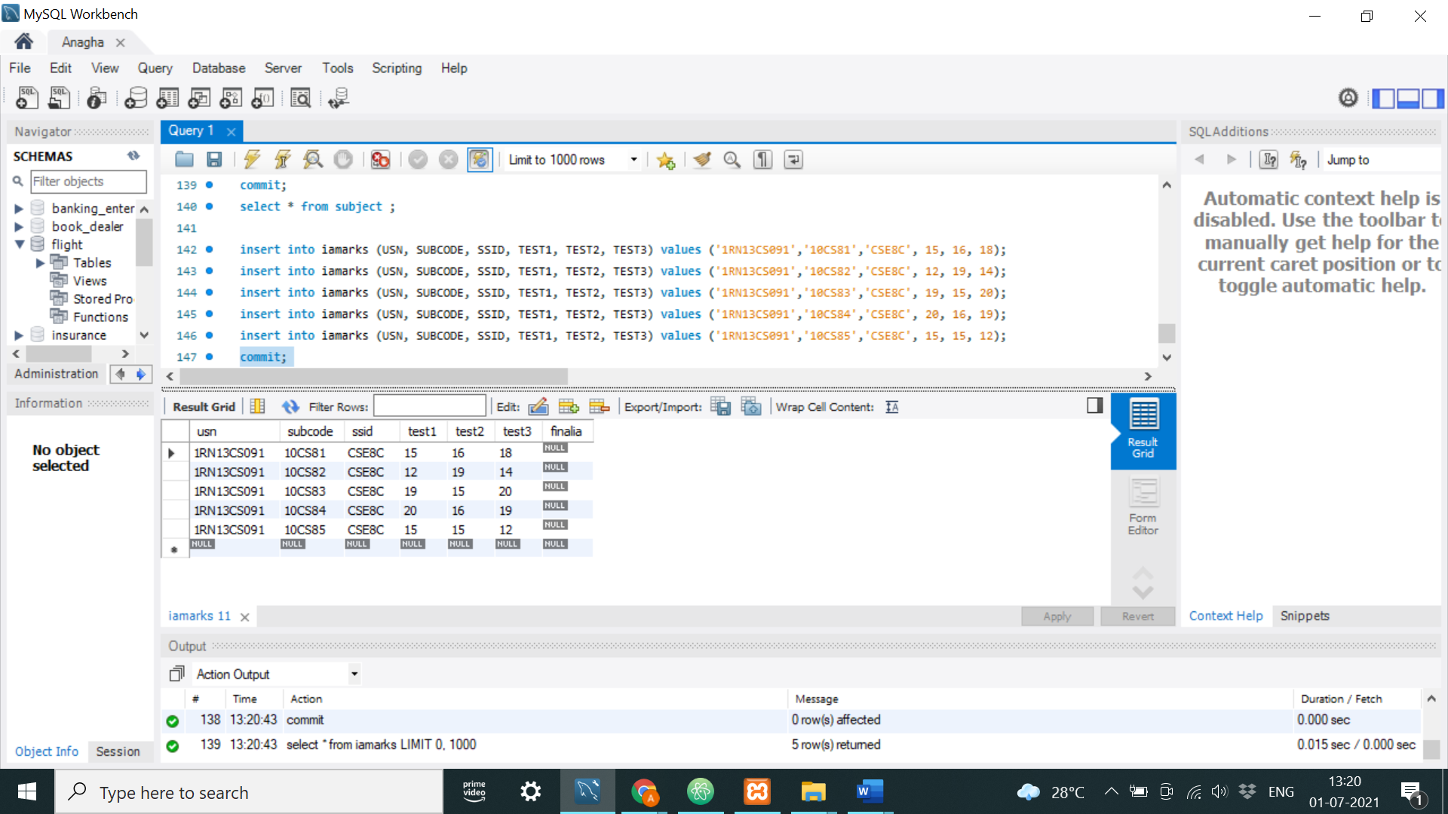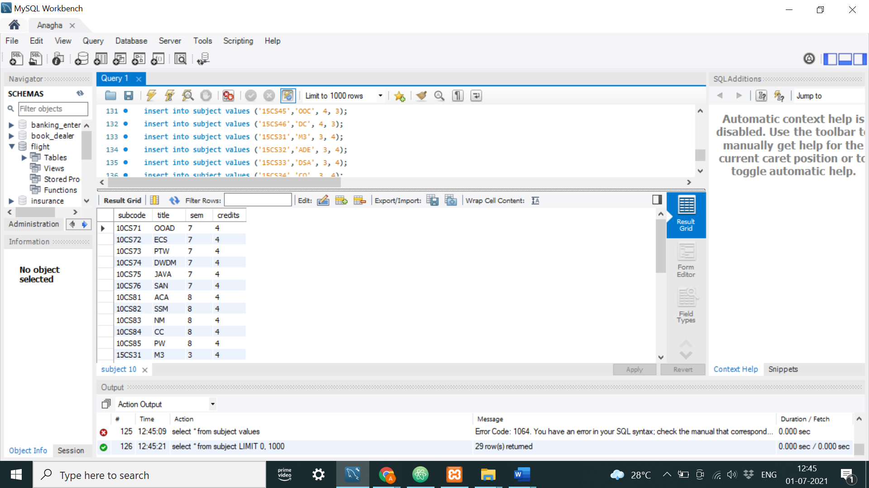

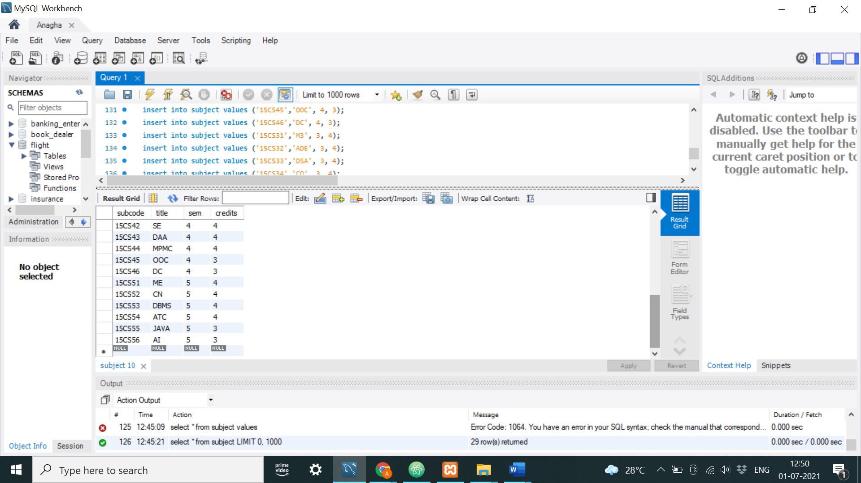

Query 1: List all the student details studying in fourth semester ‘C’ section.

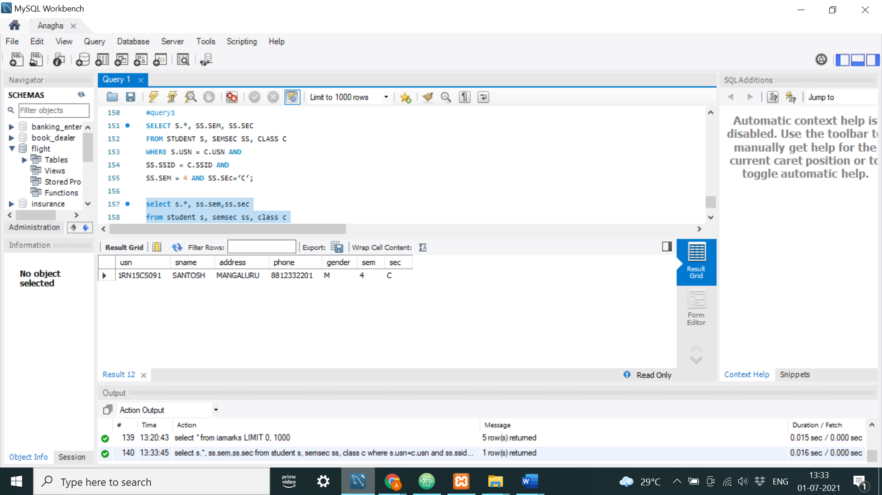

Query 2.:Compute the total number of male and female students in each semester and in each section.

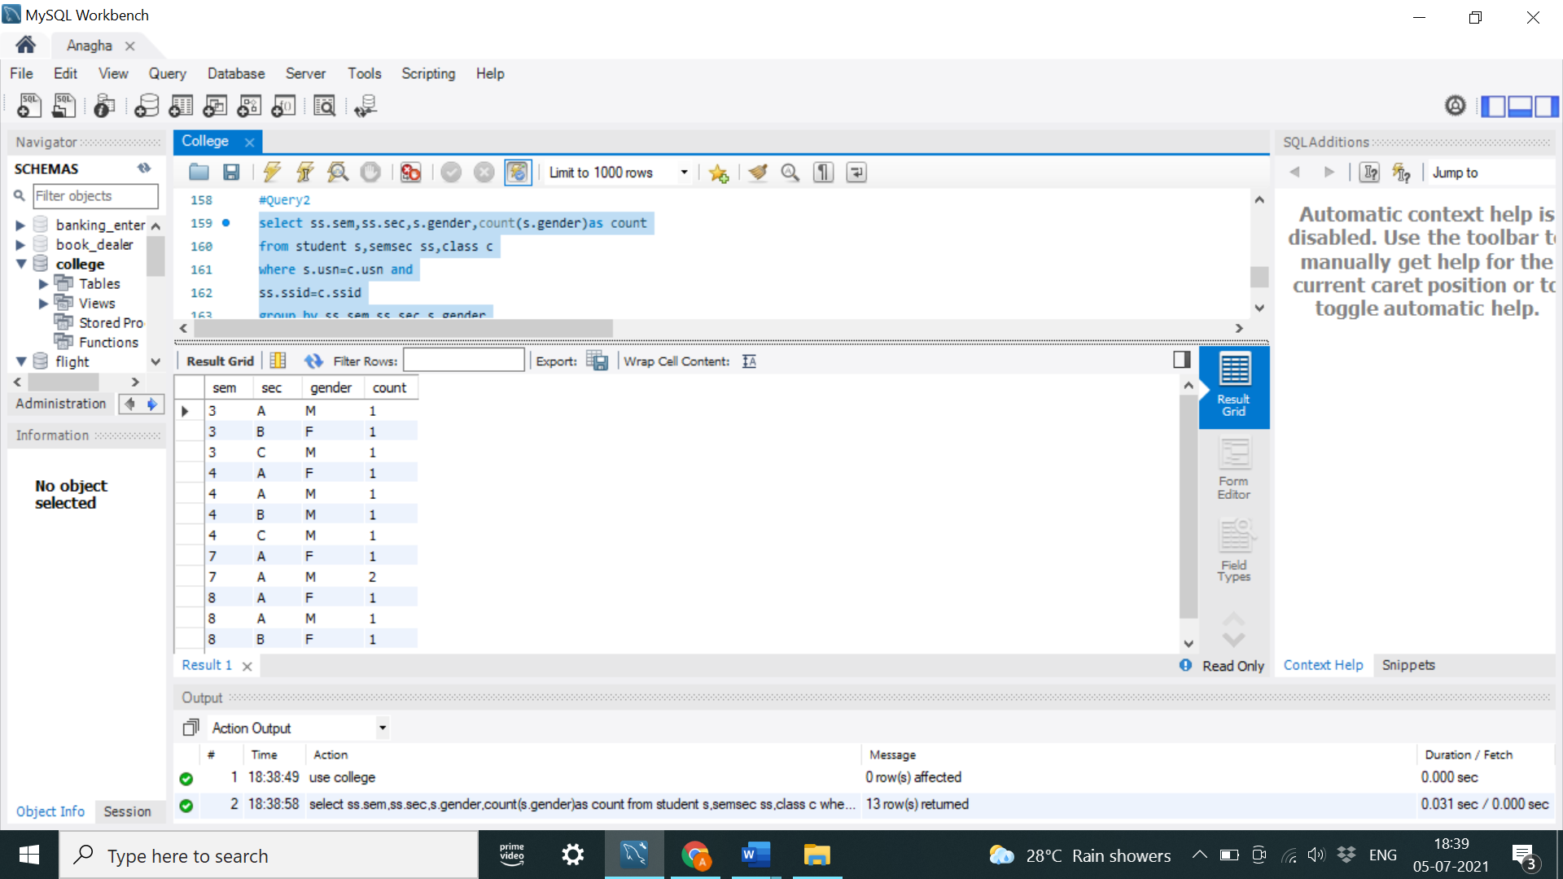



Query 3: Create a view of Test1 marks of student USN ‘1BI15CS101’ in all subjects.

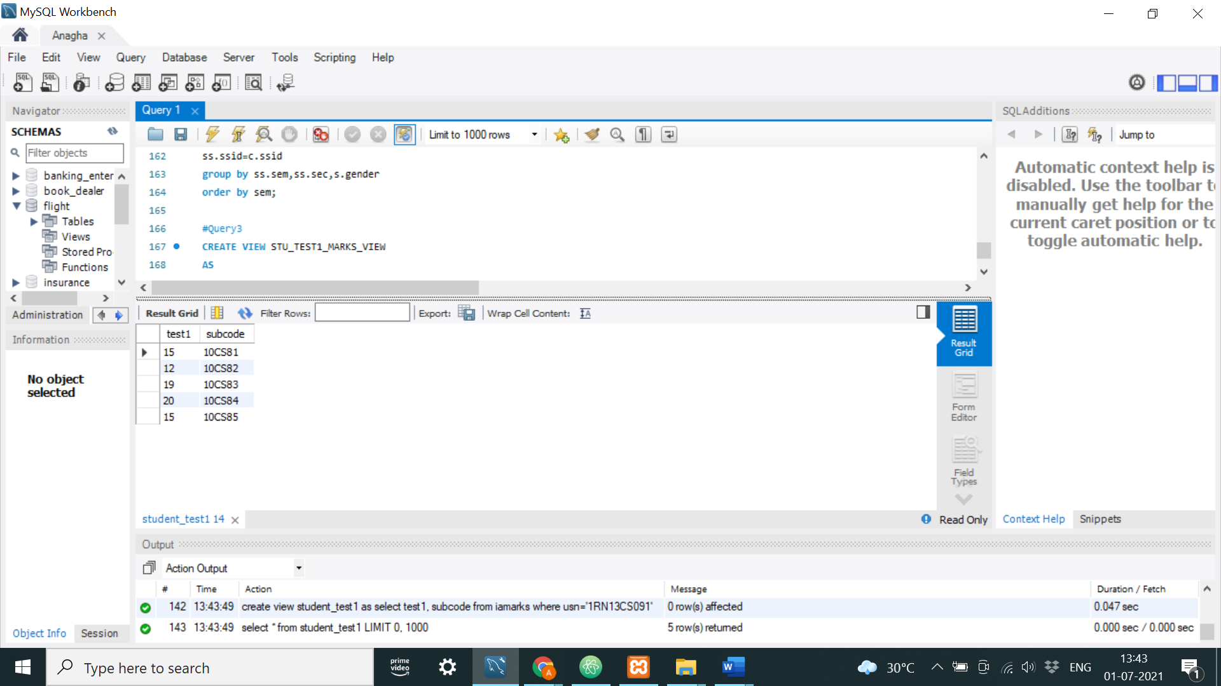

Query 4: Categorize students based on the following criterion:

If FinalIA = 17 to 20 then CAT = ‘Outstanding’

If FinalIA = 12 to 16 then CAT = ‘Average’

If FinalIA< 12 then CAT = ‘Weak’

Give these details only for 8th semester A, B, and C section students.

